Kay-Sachs Disease

Affiliation
Student’s Name
Professor’s Name
Date

Kay-Sachs Disease
Introduction
Tay-Sachs disease is a neurodegenerative disorder characterized by excessive accumulation of fats in the nerve and brain cells. The normal human body consists of enzymes that help in the breakdown of fatty acids. When the body has a deficiency of the enzymes responsible for breaking down fatty substances, fats build up in the lysosomes, making them toxic to the cell and surrounding tissue (Solovyeva et al., 2018). This abnormal accumulation of lipids leads to gradual dysfunction of the central nervous system, affecting the body's general functioning. If this disease is not addressed in the early stages, it may cause devastating health effects on the child's body and death (Butler et al., 2019). This paper discusses what Kay-Sachs disease is, the causes, diagnosis, and treatment of this disease.
Children with signs of Tay-Sachs diseases may display loss of acquired skills, exaggerated response to noise, and diminished muscle tone. The disease is inherited from infants and affects the brain nerves and the spinal cord (Ramani & Sankaran, 2020). The most common type of this disease is the infantile Tay-Sachs. This type manifests between three to six months in infants after birth. At the start, infants lose the ability to sit, crawl, or turn over. In the middle stages of the disease, infected children may develop red spots in the eyes, gradual hearing and vision loss, uncontrolled brain disturbances, and eventual paralysis (Zhang et al., 2019). If not treated at this stage, it may lower the cognitive ability of the affected children and may lead to dementia or death. The Juvenile and chronic types of the disease occur in adults but usually in rare cases. The adult form of Tay-Sachs disease occurs between adolescence and mid-30s, but the severity and the symptoms may vary from one person to another (Barritt et al., 2017).
Tay-Sachs disease results from the gene mutation of the HEXA gene, responsible for regulating hexosaminidase 'A' enzyme produced in the body to break down fatty substances. Research suggests that more than 80 different HEXA gene mutations are found in individuals with the disease (Seyrantepe et al., 2018). If the body does not make enough HEXA protein, the defective gene appears, leading to Tay-Sachs disease. In addition, inheriting two copies of the HEXA gene leads to deficiency in hexosaminidase A enzyme. As a result, fatty substances in the form of GM2-ganglioside accumulate in the nerve and brain cells leading to the dysfunction of the central nervous system (Dersh et al., 2016). The disease is then inherited through autosomal recession from parent to the child, which means that children must have two copies of the defective gene to inherit the disease. If only one parent passes the faulty gene to a child, they became a carrier. Therefore, the child would not inherit the disease but can pass it to their children later.
Methods
Diagnosis
Tay-Sachs can be diagnosed through medical evaluation and clinical tests such as blood tests to determine the level of hexosaminidase A in the body. The level of hexosaminidase A is significantly low in people with Tay-Sachs disease and nearly absent in children with the infantile type of this disease. Medical professionals can also use molecular genetic testing to confirm the presence of Tay-Sachs disease (Butler et al., 2019). Through this process, doctors can detect HEXA gene mutations that cause the disorder. However, molecular genetic testing is only available in specialized laboratories, so it cannot be conducted at all healthcare system levels.
Diagnosis of Tay-Sachs disease can also be confirmed prenatally using specialized tests such as chorionic villus sampling (CVS) and amniocentesis (Zhang et al., 2019). During CVS, doctors remove tissue samples from the placenta, while amniocentesis involves taking a sample of the fluid surrounding a developing fetus. Doctors study these samples to determine the presence or absence of hexosaminidase A in the blood. These tests are mainly used in situations where the disease has affected family members before. Medical professionals can also use blood tests to determine whether individuals are carriers of the disease (Poswar et al., 2019). Couples can be tested before delivery to determine whether they have a copy of the HEXA genes that can be passed to the infant.
Treatment
Tay-Sachs disease does not have a specified type of treatment. However, the treatment of this disease is towards the symptoms apparent in different individuals. The goal of medical providers and pediatricians is to comfort and psychological support the patients and their families. Doctors can provide medication such as anti-seizure medications to reduce the adversity of the symptoms in children. Additionally, infected children are can develop lung infections that may cause breathing problems (Solovyeva et al., 2018). Respiratory care is essential to remove mucus from the lungs for easy breathing. Further, feeding tubes can be of great help to assist children in swallowing food and liquids. As the effects of the disease become more severe, children may benefit from physical therapy to maintain the ability to move and keep body joints flexible. Research suggests that physical therapy can delay joint stiffness and pain related to shortened muscles (Seyrantepe et al., 2018).
Discussion
Investigational therapies are currently underway to create an enzyme replacement therapy (ERT) for Tay-Sachs disease. ERT involves the replacement of the absent enzymes in people who have a deficiency in a certain enzyme. Synthetic versions of body enzymes responsible for breaking down fats have been developed to treat people diagnosed with lysosomal storage diseases such as Gaucher disease and Fabry syndrome (Poswar et al., 2019). However, efforts to apply the treatment on people with Tay-Sachs disease have turned unsuccessful due to the inability to pass the replacement enzyme through the blood-brain barrier. The brain forms a protective network of cells and blood vessels to restrict materials from entering, thus preventing the replacement enzymes from functioning efficiently.
Scientists are also exploring gene therapy as a possible solution for disorders related to Tay-Sachs disease. In gene therapy, the faulty gene in children with the disorder is replaced with a normal gene to prevent the development of the disease and promote rapid production of active enzymes. Theoretically, this form of gene therapy is likely to make a "cure" if there is a permanent transfer of normal genes which produce functional enzymes (Lew et al., 2015). Moreover, research suggests that the development of the pyrimethamine drug has had a positive impact on the Tay-Sachs disorder (Poswar et al., 2019). Affected people who took the drug displayed signs of improved activity of hexosaminidase A. However, there was no acknowledgeable improvement in psychiatric or neurological symptoms. Therefore, more research is necessary to determine the clinical impact of the medication in treating this disease.

Figure 1. An image of cherry red spot in a 9-month-old boy with Tay-Sachs disease (Ramani & Sankaran, 2020).
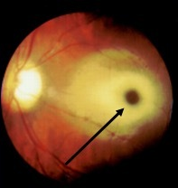
Figure 2. Human gene therapy (Dunbar et al., 2018).
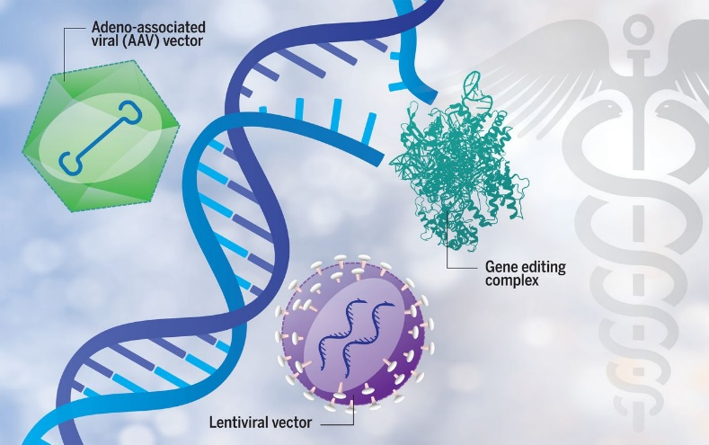
Conclusion
Tay-Sachs disease is an autosomal neurodegenerative disorder that develops due to deficiency in hexosaminidase A in the body. Accumulation of fatty substances in the body affects the normal functioning of the central nervous system leading to the development of the disorder. However, medical providers can diagnose children with this disease before birth or after birth through blood tests and samples of fluids around the fetus. Scientific research has not approved any specific method of treatment for the Tay-Sachs disease. The available treatment involves psychological support and therapy to reduce the impacts of the disease. Research to develop new methods of treatment is ongoing to ensure patients with Tay-Sachs disease can be treated.

References
Barritt, A. W., Anderson, S. J., Leigh, P. N., & Ridha, B. H. (2017). Late-onset Tay–sachs disease. Practical neurology, 17(5), 396-399.
Butler, M. G., Miller, J. L., & Forster, J. L. (2019). Prader-Willi syndrome-clinical genetics, diagnosis and treatment approaches: an update. Current pediatric reviews, 15(4), 207-244.
Dersh, D., Iwamoto, Y., & Argon, Y. (2016). Tay–Sachs disease mutations in HEXA target the α chain of hexosaminidase A to endoplasmic reticulum–associated degradation. Molecular biology of the cell, 27(24), 3813-3827.
Dunbar, C. E., High, K. A., Joung, J. K., Kohn, D. B., Ozawa, K., & Sadelain, M. (2018). Gene therapy comes of age. Science, 359(6372).
Lew, R. M., Burnett, L., Proos, A. L., & Delatycki, M. B. (2015). Tay-Sachs disease: current perspectives from Australia. The application of clinical genetics, 8, 19.
Poswar, F. D. O., Vairo, F., Burin, M., Michelin-Tirelli, K., Brusius-Facchin, A. C., Kubaski, F., ... & Giugliani, R. (2019). Lysosomal diseases: Overview on current diagnosis and treatment. Genetics and molecular biology, 42(1), 165-177.
Ramani, P. K., & Sankaran, B. P. (2020). Tay-Sachs Disease. StatPearls.
Seyrantepe, V., Demir, S. A., Timur, Z. K., Von Gerichten, J., Marsching, C., Erdemli, E., ... & Miyagi, T. (2018). Murine Sialidase Neu3 facilitates GM2 degradation and bypass in mouse model of Tay-Sachs disease. Experimental neurology, 299, 26-41.
Solovyeva, V. V., Shaimardanova, A. A., Chulpanova, D. S., Kitaeva, K. V., Chakrabarti, L., & Rizvanov, A. A. (2018). New approaches to tay-sachs disease therapy. Frontiers in physiology, 9, 1663.
Zhang, J., Chen, H., Kornreich, R., & Yu, C. (2019). Prenatal diagnosis of Tay-Sachs disease. In Prenatal diagnosis (pp. 233-250). Humana Press, New York, NY.

